5/27/2026
Shekhar Podutwar
27/5/2026
Jenkins Pipeline Setup on AWS EC2 Instance
Setup on AWS EC2 Instance

Contents

Document Version History……………………………….…………………………………………….1
Introduction…………………….…………………………………………………………………………….2
Objectives…………………….………………………..….………………………………………………….3
Tools & Technologies Used…………………………………………………………………………….4
Architecture Overview ………………………………………………………………………………….5
Step-by-Step Implementation …………………………………..………………………………….6
Conclusion…………………………………………………………………………………………………….7

Document Version History

Version Number | Date Modified | Author | Changes
Draft | 27/5/2026 | Shekhar | Draft Version

Introduction
This project focuses on setting up and configuring Jenkins on an AWS EC2 instance to implement Continuous Integration and Continuous Deployment (CI/CD) automation using Jenkins Pipelines. The project involved launching an EC2 instance in Amazon Web Services, connecting the server using PuTTY, installing Java and Jenkins, configuring repositories and services, opening required ports, and creating automated Jenkins pipeline jobs.
The setup enabled automated build and deployment workflows, helping improve software delivery speed, reduce manual tasks, and increase deployment reliability.

Objectives

- Launch and configure AWS EC2 instance for Jenkins setup.
- Connect EC2 server securely using PuTTY and SSH.
- Install Java and Jenkins on Linux server environment.
- Configure Jenkins repository and required dependencies.
- Start and manage Jenkins services successfully.
- Open and configure required network ports for Jenkins access.
- Create and execute Jenkins Pipeline jobs for CI/CD automation.
- Gain practical experience in cloud-based DevOps automation.
Tools and Technologies
Category | Tools / Technologies
Cloud Platform | Amazon Web Services (AWS)
Compute Service | Amazon EC2
Automation Tool | Jenkins
Operating System | Linux (Ubuntu / Amazon Linux)
Remote Access Tool | PuTTY / SSH
Dependency Package | Java (OpenJDK)
Repository Management | Jenkins Repository & GPG Key
CI/CD Implementation | Jenkins Pipeline
Networking | Security Groups, Port 8080 Configuration
Version Control | GitHub (Optional Integration)

Architecture Overview
Developer
↓
AWS EC2 Instance
↓
Linux Server Configuration
↓
Java Installation
↓
Jenkins Repository & GPG Key Configuration
↓
Jenkins Installation & Service Start
↓
Port 8080 Open in Security Group
↓
Access Jenkins Web Dashboard
↓
Create Jenkins Pipeline Job
↓
Automated Build & Deployment Workflow
Step-by-Step Implementation
Step 1: Login AWS and create an instance
- Select AMI (Ubuntu Server 24.04 LTS (HVM), SSD Volume Type)
- Create a Jenkins key pair

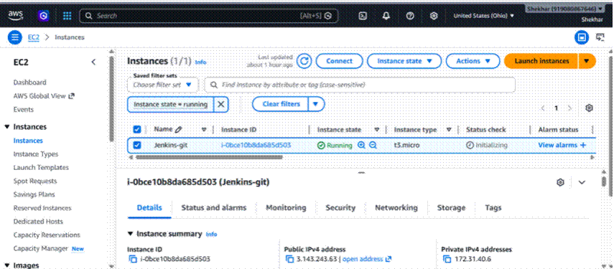

Step 2: Connect putty and run following commands
- ubuntu
- Sudo su -

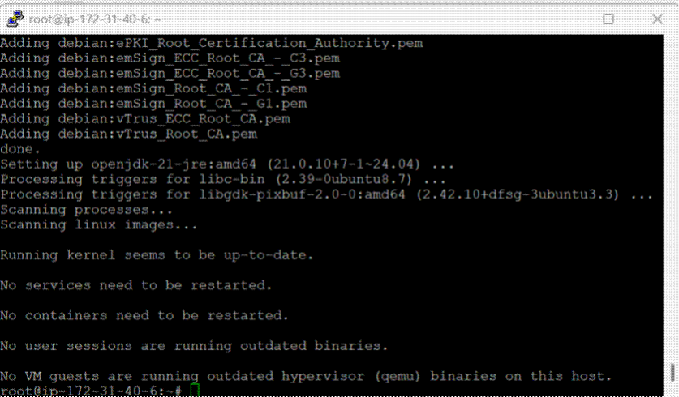

- Update the repository.
(apt update –y)

- Install the Java package.
(apt install fontconfig openjdk-21-jre –y)

- Download the official Jenkins GPG key.
wget -O /etc/apt/keyrings/jenkins-keyring.asc https://pkg.jenkins.io/debian-stable/jenkins.io-2026.key

- Add the Jenkins repository to the system. echo "deb [signedby=/etc/apt/keyrings/jenkins-keyring.asc]" https://pkg.jenkins.io/debian-stable binary/ | sudo tee
/etc/apt/sources.list.d/jenkins.list > /dev/null

- Update the repository again.
(apt update –y)

- Install Jenkins.
(apt install jenkins –y)

- Start the Jenkins service.
(systemctl start jenkins)

- Add the Jenkins user to the sudoers file. vim /etc/sudoers jenkins ALL=(ALL) NOPASSWD: ALL

Step 3: Open port no 8080
- Security --> security group --> edit inbound rule --> add rule
- Must be select Any-where-Ipv4

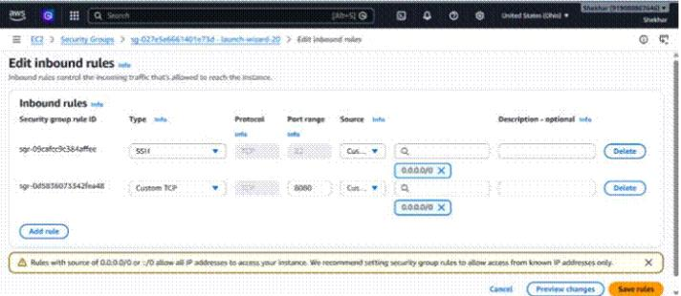
Step 4: To configure Jenkins
- Connect to http: public_ip:8080 from our browser.
- We will be able to access Jenkins through its management interface:
- Default home directory for Jenkins
(/var/lib/jenkins)
- workspace directory of Jenkins.
(/var/lib/jenkins/workspace/job1/file1)
- For password
(cat past path)
(cat /var/lib/jenkins/secrets/initialAdminPassword)
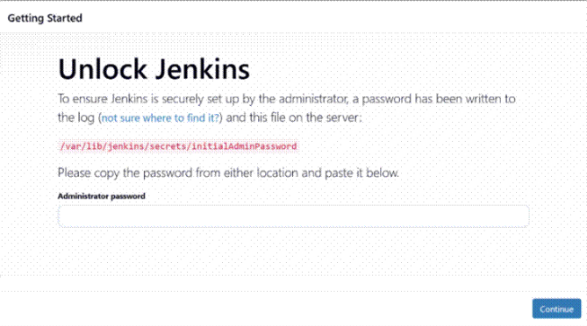

Step 5: Now you can access Jenkins dashboard
- Select installs suggested plugins
- Then set up username and password
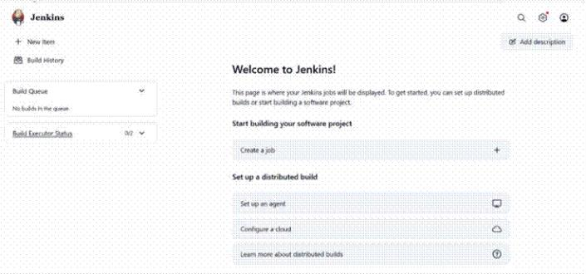

Step 6: Create a job in Jenkins
- Now you can create job in Jenkins
- New item--> job--> Pipeline
- Pipeline --> script (add pipeline)
- Apply and save
- Build job
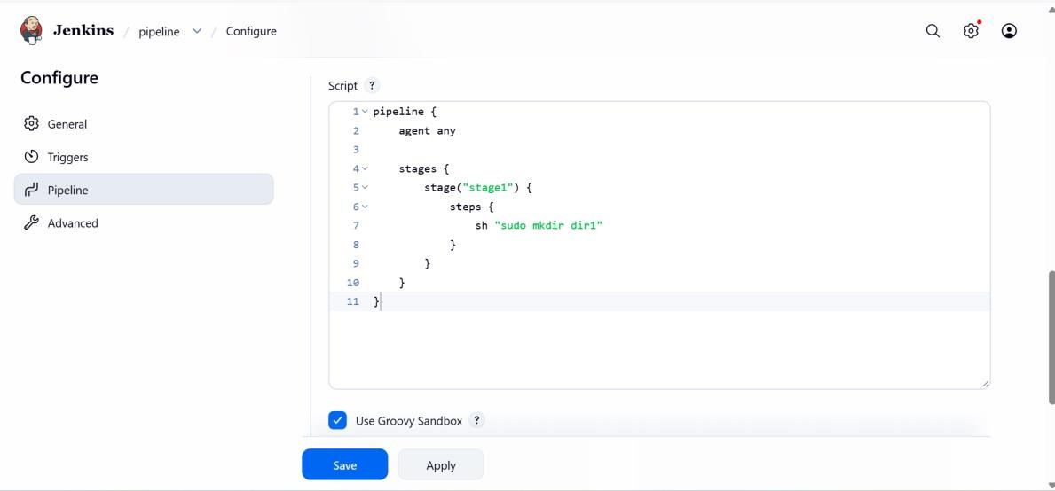
Step 7: default Jenkins directory
- Now you can create job in Jenkins
- Default home directory
(cd /var/lib/jenkins/)
- workspace directory of Jenkins.
(Workspace/project name)

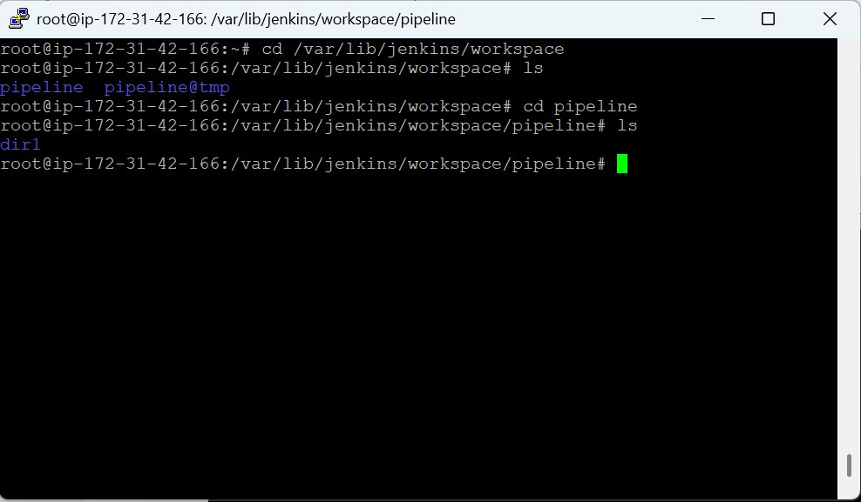

Conclusion
This project successfully demonstrated the installation and configuration of Jenkins on an AWS EC2 instance for implementing CI/CD pipeline automation. The setup included Java installation, Jenkins repository configuration, service management, network configuration, and Jenkins Pipeline creation. By integrating Jenkins with cloud infrastructure, the project improved deployment automation, reduced manual efforts, and enhanced software delivery efficiency. This project also provided practical hands-on experience in AWS server management, Jenkins administration, CI/CD implementation, and DevOps practices using Amazon Web Services.

